**Hamster Accommodation**

**Minimum Size Requirements: 80cm x 50cm x 50cm**

The accommodation must allow for an appropriately sized wheel, plenty of enrichment and deep substrate.

**Suitable cages currently available on the market (as of 06.02.23).**

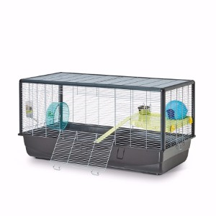

**Savic Plaza Cage**

Dimensions: 50cm x 100cm x 50cm

Bar spacing: 9.5mm

Base depth: 6.5 inches

Currently available at:

<https://www.petsathome.com/shop/en/pets/savic-plaza-hamster-and-rat-cage>

<https://www.amazon.co.uk/Savic-Hamster-Plaza-Cage-100/dp/B071RNWH11/ref=sr_1_1?keywords=plaza+savic&qid=1638197935&rdc=1&sr=8-1>

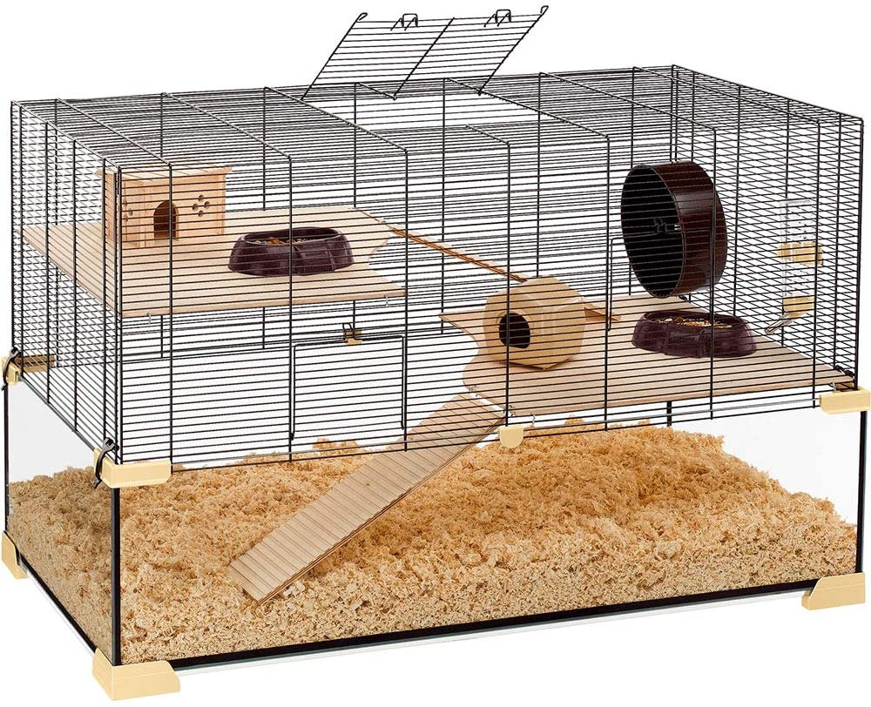

**Ferplast Karat 100**

Dimensions: 100cm x 61cm x 50cm

Bar spacing: 9.5mm

Base depth: 6.5 inches

The deeper base of this cage allows for more substrate so that hamsters can burrow.

Currently available at:

<https://www.amazon.co.uk/Ferplast-Karat-57056317W1-Hamster-Mouse/dp/B00L180ZMS/ref=sr_1_2?keywords=karat+100&qid=1638198027&rdc=1&sr=8-2>

**Paw hut wooden hamster cage**

Dimensions: 115cm x 60cm x 58cm

Bar spacing: N/A

Base depth:

This cage exceeds the minimum standard offering a good amount of floor space. The solid sides allow for deep bedding to be used so that hamsters can burrow.

Currently available at: [PawHut Wooden Hamster Cage Mouse Rats Mice Rodent Small Animals Hutch Exercise Play House Pen 115L x 60W x 58H(cm) : Amazon.co.uk: Pet Supplies](https://www.amazon.co.uk/Pawhut-Wooden-Hamster-Animals-Exercise/dp/B07NP4DJN3/ref=sr_1_3_sspa?keywords=large+hamster+cage&qid=1667744197&sr=8-3-spons&psc=1)

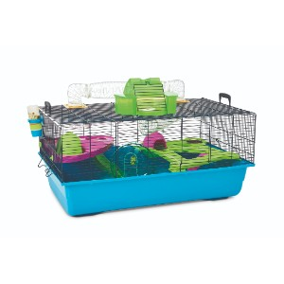

**Savic Hamster Heaven X Large Cage**

Dimensions: 80cm x 50cm x 50cm

Bar spacing: 9.5mm

Base depth: 6.5 inches

This cage comes with built in levels and a small tunnel system. The wheel provided is too small so must be replaced.

Currently available at:

<https://www.petsathome.com/shop/en/pets/hamster-heaven-hamster-cage-%28online-only%29>

<https://www.zooplus.co.uk/shop/small_pets/hutches_cages/hamster_cages/hamster_cages/197362>

<https://www.amazon.co.uk/Savic-Hamster-Heaven-Navy-Blue/dp/B003QRPAR2>

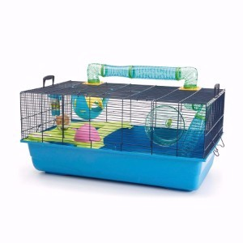

**Savic Sky Hamster Metro Cage**

Dimensions: 80cm x 50cm x 50cm

Bar spacing: 9.5mm

Base depth: 6.5 inches

This cage comes with built in levels and a small tunnel system. The wheel provided is too small so must be replaced.

Currently available at:

<https://www.petsathome.com/shop/en/pets/savic-sky-metro-hamster-cage-7128439p--1>

<https://www.amazon.co.uk/Savic-Hamster-Navy-Blue-Cage/dp/B003XLEFXG?th=1>

Suitable wheels for hamster

Hamsters will often require a larger wheel to the ones supplied when you buy a cage. A suitable wheel for hamsters should allow them to run without arching their back or raising their head. This is usually around 25cm – 30cm depending on the species of hamster.

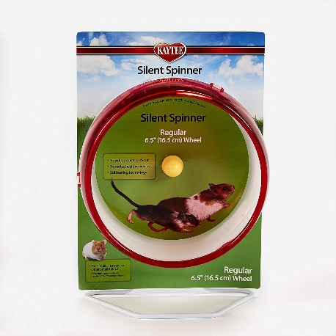

**Kaytee Silent Spinner**

Dimensions: 10 inches

Currently available at:

<https://www.amazon.co.uk/dp/B000A7DFUU/ref=emc_b_5_i>

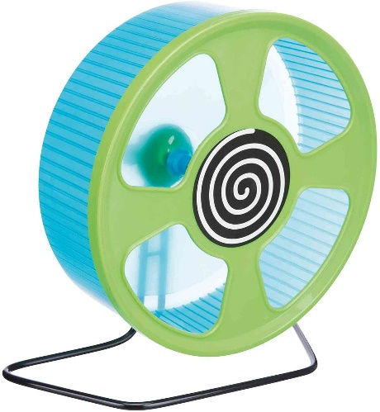

**Trixie Exercise wheel**

Dimensions: 28cm

Currently available at:

<https://www.amazon.co.uk/Trixie-Exercise-wheel-plastic-20/dp/B0042LHXP8>

Homemade accommodation

Due to the lack of suitable accommodation available on the market, many pet owners are now creating their own small animal enclosures. Here are some examples and ideas:

**Ikea ‘detolf’ display unit with a mesh topper**

163cm x 43cm x 37cm (without topper)

Although the width and height are less than the minimum requirements, this is more than made up for in length giving a very large space overall and allowing for deep substrate. It can be extended with the addition of a topper, or otherwise requires a mesh lid to be made and fitted.

NB: This detolf has been set up with enrichment for mice, not hamsters.

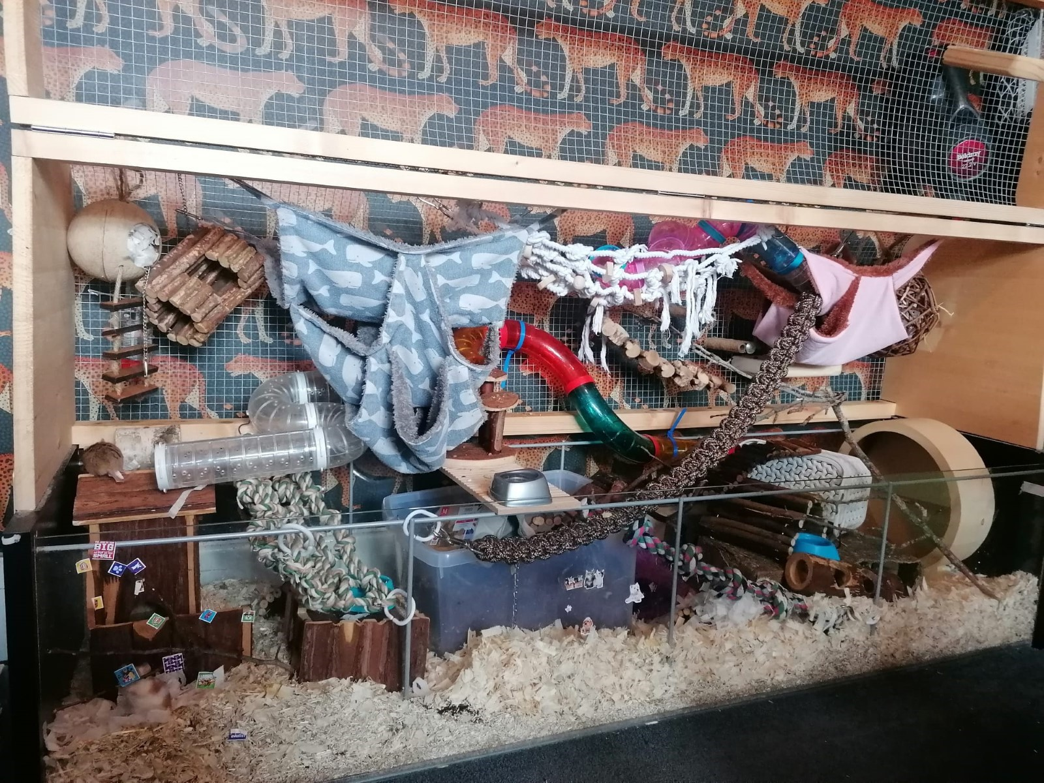

Detolf can be purchased here: <https://www.ikea.com/gb/en/p/detolf-glass-door-cabinet-white-80269122/>

Lids and toppers often available to purchase at [www.etsy.com](http://www.etsy.com/)

Currently available here;

<https://www.etsy.com/uk/listing/1156193970/ikea-detolf-cage-lids?ga_order=most_relevant&ga_search_type=all&ga_view_type=gallery&ga_search_query=ikea+detolf+lid&ref=sr_gallery-1-3&organic_search_click=1>

Or here;

<https://www.etsy.com/uk/listing/1354588991/detolf-cage-lid?ga_order=most_relevant&ga_search_type=all&ga_view_type=gallery&ga_search_query=ikea+detolf+lid&ref=sc_gallery-1-1&frs=1&plkey=ef9fa058b491b333eadd0519ecab68545a20c9a0%3A1354588991>

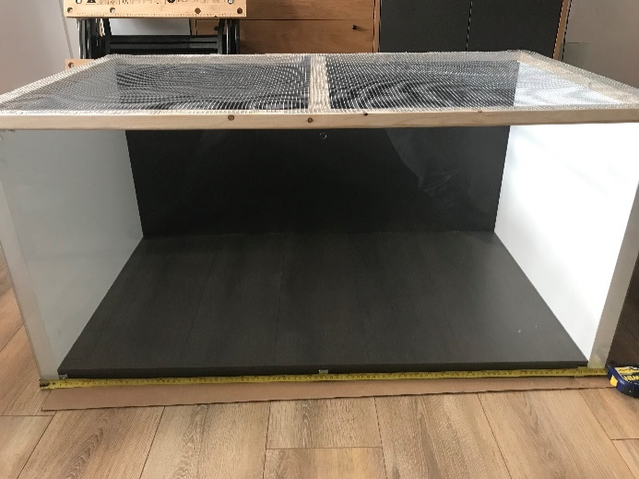

Extra large mouse cage made from two Ikea bookshelves