**Mouse Accommodation**

**Minimum Size Requirements: 80cm x 50cm x 50cm**

The accommodation must allow for an appropriately sized wheel, plenty of enrichment, and enough space for multiple mice. The base of most traditional cages does not allow for deep enough substrate for the mice to burrow in so a digging box should be added or perspex fitted to the lower part of the cage.

**Suitable cages currently available on the market (as of 12.08.21).**

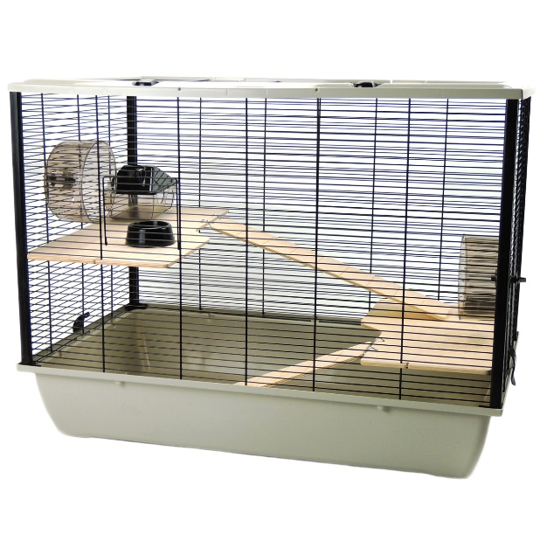

**Little Friends Langham Large Rat Hamster Mouse Cage**

Dimensions: 78cm x 48cm x 58cm

Bar spacing: 1cm

Base depth: 12cm

Whilst falling short in terms of width, this cage does have additional depth and some handy levels. The wheel included is too small so must be replaced.

Currently available at:

<https://www.littlepetwarehouse.co.uk/products/the-langham-tall-rat-and-hamster-cage-with-two-floors-grey.html>

<https://www.amazon.co.uk/Little-Friends-Langham-Hamster-Floors/dp/B005CAYRSE>

<https://www.ebay.co.uk/p/8034416325>

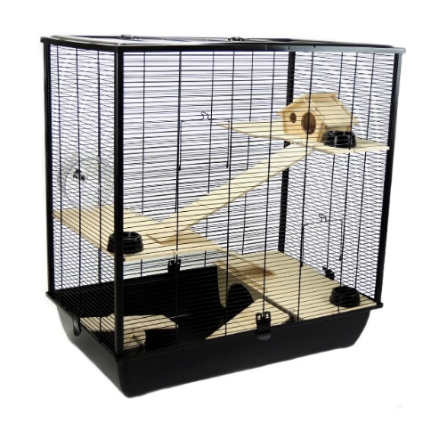

**The Plaza Tall Rat and Hamster Cage**

Dimensions: 78cm x 80cm x 48cm

Bar spacing: 1cm

Base depth: 12cm

Due to the height of this cage, it gives plenty of scope for hanging toys. The bar spacing also allows for the secure housing of mice. The wheel is too small so must be replaced.

Currently available at:

<https://www.littlepetwarehouse.co.uk/products/the-plaza-tall-rat-and-hamster-cage-with-three-floors-black.html>

<https://www.ebay.co.uk/p/2032731660>

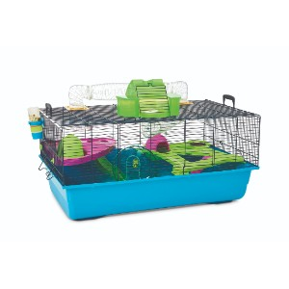

**Savic Hamster Heaven X Large Cage**

Dimensions: 80cm x 50cm x 50cm

Bar spacing: 9.5mm

Base depth: 6.5 inches

This cage comes with built in levels and a small tunnel system which can be extended. The wheel provided is too small so must be replaced.

Currently available at:

<https://www.petsathome.com/shop/en/pets/hamster-heaven-hamster-cage-%28online-only%29>

<https://www.zooplus.co.uk/shop/small_pets/hutches_cages/hamster_cages/hamster_cages/197362>

<https://www.amazon.co.uk/Savic-Hamster-Heaven-Navy-Blue/dp/B003QRPAR2>

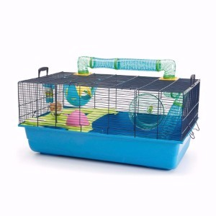

**Savic Sky Hamster Metro Cage**

Dimensions: 80cm x 50cm x 50cm

Bar spacing: 9.5mm

Base depth: 6.5 inches

This cage comes with built in levels. The wheel provided is too small so must be replaced.

Currently available at:

<https://www.petsathome.com/shop/en/pets/savic-sky-metro-hamster-cage-7128439p--1>

<https://www.amazon.co.uk/Savic-Hamster-Navy-Blue-Cage/dp/B003XLEFXG?th=1>

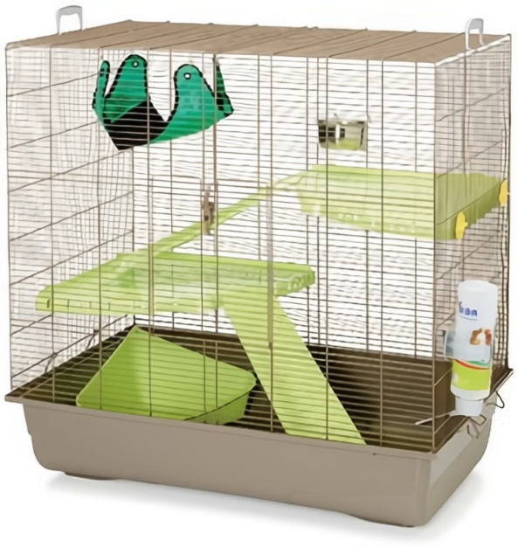

**Savic Freddy Max 2**

Dimensions: 80cm x 50cm x 80cm

Bar spacing: 9.5mm

Base depth: 6.5 inches

Currently available at:

<https://www.petsathome.com/shop/en/pets/savic-freddy-2-max-rat-ferret-cage>

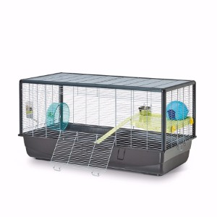

**Savic Plaza Cage**

Dimensions: 50cm x 100cm x 50cm

Bar spacing: 9.5mm

Base depth: 6.5 inches

Currently available at:

<https://www.petsathome.com/shop/en/pets/savic-plaza-hamster-and-rat-cage>

<https://www.amazon.co.uk/Savic-Hamster-Plaza-Cage-100/dp/B071RNWH11/ref=sr_1_1?keywords=plaza+savic&qid=1638197935&rdc=1&sr=8-1>

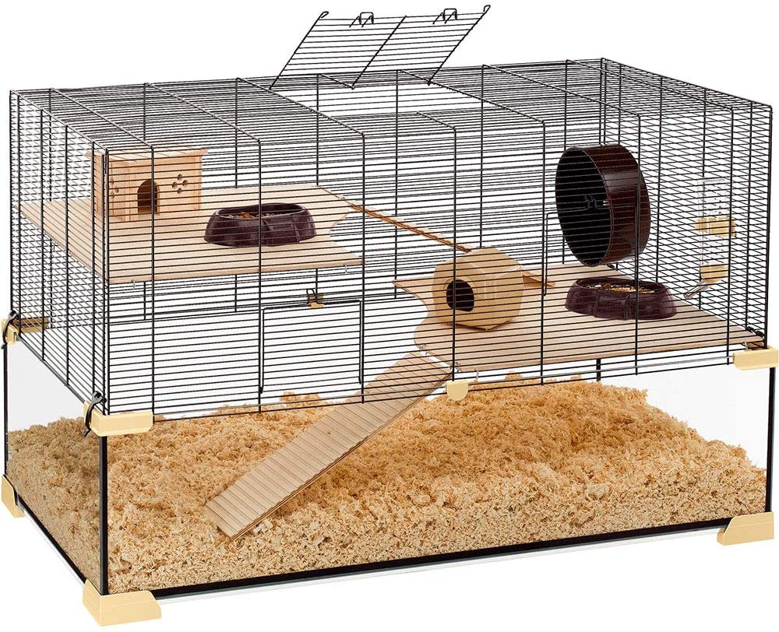

**Ferplast Karat 100**

Dimensions: 100cm x 61cm x 50cm

Bar spacing: 9.5mm

Base depth: 6.5 inches

Currently available at:

<https://www.amazon.co.uk/Ferplast-Karat-57056317W1-Hamster-Mouse/dp/B00L180ZMS/ref=sr_1_2?keywords=karat+100&qid=1638198027&rdc=1&sr=8-2>

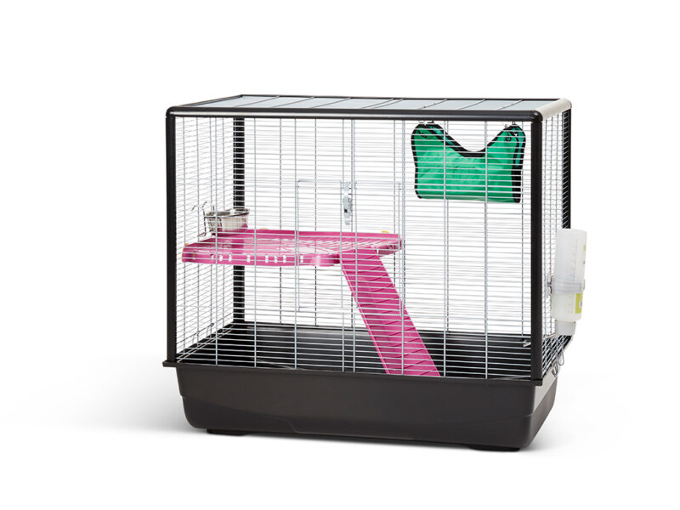

**Zeno 2**

Dimensions: 80cm x 50cm x 70cm

Bar spacing: 9.5mm

Base depth: 6.5 inches

Currently available at:

<https://www.amazon.co.uk/Savic-Zeno-Knock-Animal-Small/dp/B009WMUZKM>

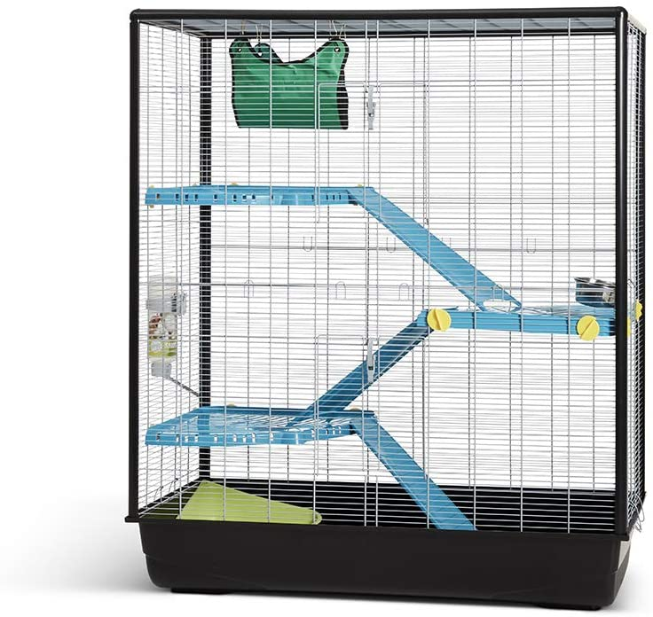

**Zeno 3**

Dimensions: 100cm x 50cm x 116cm

Bar spacing: 9.5mm

Base depth: 6.5 inches

Currently available at: <https://www.amazon.co.uk/Savic-Knock-Empire-Small-Animal/dp/B01D1CDEOM>

Suitable wheels for mice

Mice will often require a larger wheel to the ones supplied when you buy a cage. A suitable wheel for mice should be no smaller than 8 inches (20cm).

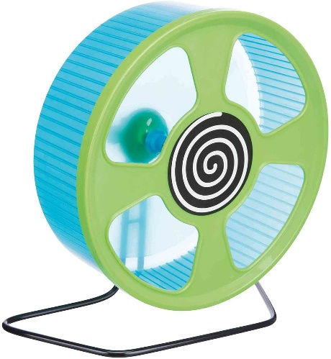

**Trixie Exercise wheel**

Dimensions: 20cm

Currently available at:

<https://www.amazon.co.uk/Trixie-Exercise-wheel-plastic-20/dp/B0042LHXP8>

Homemade accommodation

Due to the lack of suitable accommodation available on the market, many pet owners are now creating their own small animal enclosures. Here are some examples and ideas:

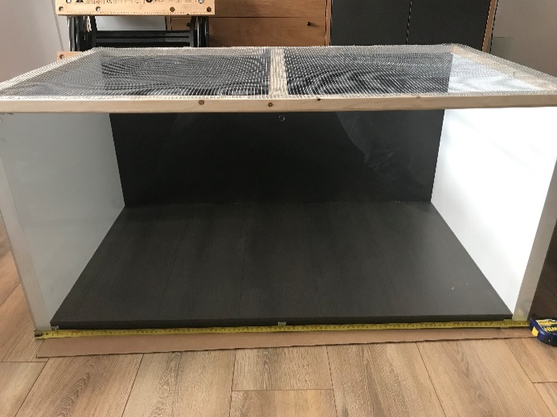

Extra large mouse cage made from two Ikea bookshelves

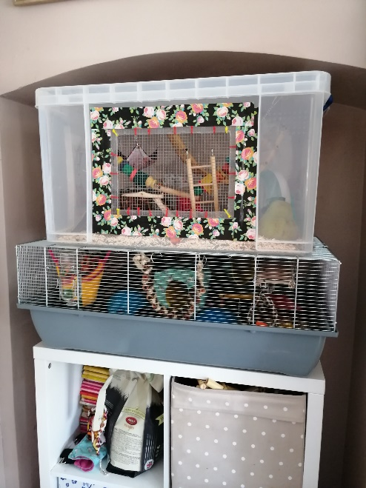

A small mouse cage extended by securing a storage box on top

**Ikea ‘detolf’ display unit with a mesh topper**

163cm x 43cm x 37cm (without topper)

Although the width and height are less than the minimum requirements, this is more than made up for in length giving a very large space overall and allowing for deep substrate. It can be extended with the addition of a topper, or otherwise requires a mesh lid to be made and fitted.

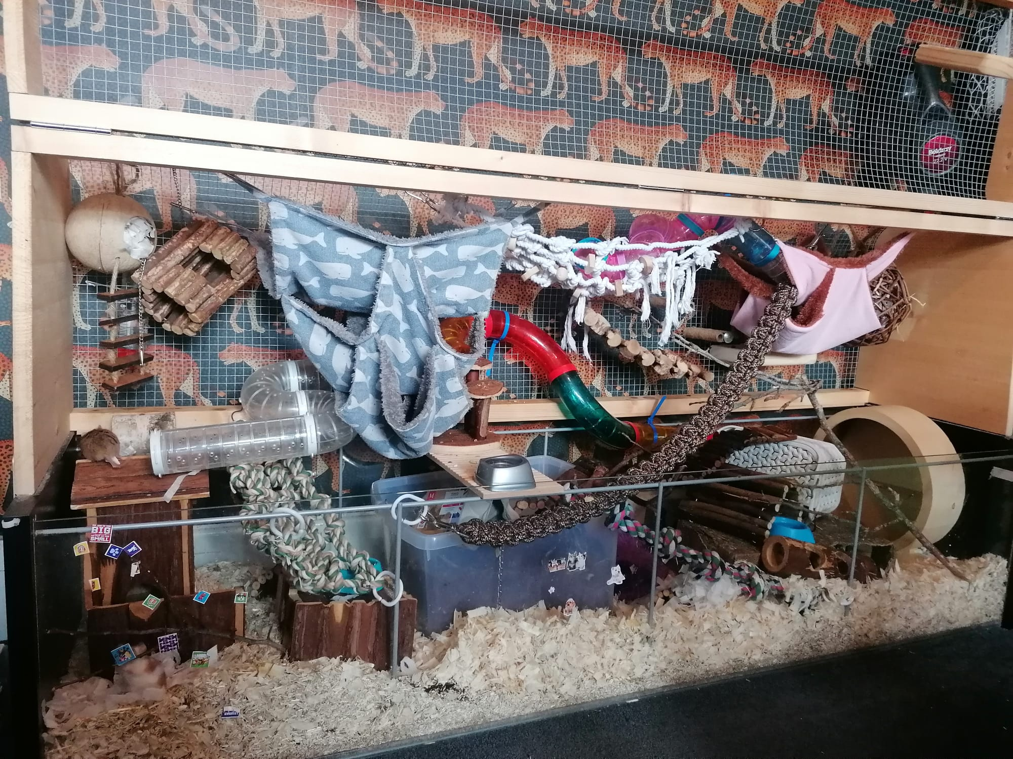

Detolf can be purchased here: <https://www.ikea.com/gb/en/p/detolf-glass-door-cabinet-white-80269122/>

Lids and toppers often available to purchase at [www.etsy.com](http://www.etsy.com)

Currently available here;

<https://www.etsy.com/uk/listing/1156193970/ikea-detolf-cage-lids?ga_order=most_relevant&ga_search_type=all&ga_view_type=gallery&ga_search_query=ikea+detolf+lid&ref=sr_gallery-1-3&organic_search_click=1>

Or here;

<https://www.etsy.com/uk/listing/1354588991/detolf-cage-lid?ga_order=most_relevant&ga_search_type=all&ga_view_type=gallery&ga_search_query=ikea+detolf+lid&ref=sc_gallery-1-1&frs=1&plkey=ef9fa058b491b333eadd0519ecab68545a20c9a0%3A1354588991>