

**Chinchilla Accommodation**

**Minimum Size Requirements for 2 – 3 chinchillas:**

**90cm x 60cm x 120cm (these measurements only relate to useable living space; any storage shelves or stands should not form part of these measurements)**

Accommodation must allow for an appropriately sized wheel, plenty of enrichment and enough space to jump and climb. Some of the cages on the market have plastic bases or shelves which are not suitable chinchillas so these should be removed. Wood (or wood wrapped in fleece) can be inserted instead or a custom metal bases can be made.

Additional ledges can be added to the cage to add more opportunities for jumping such as these: <https://www.petsathome.com/shop/en/pets/lookout-ledge>

**Suitable cages currently available on the market (as of 12.08.21)**

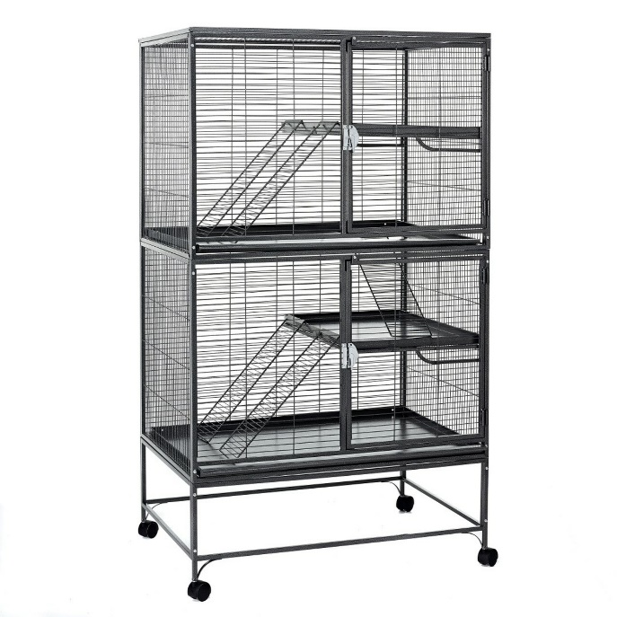

**Metal Aventura Huge Rat, Ferret & Chinchilla Cage**

Dimensions: 92cm x 64cm x 124cm (160cm with stand)

Bar spacing: 12-14mm

This cage benefits from being all metal so no need to change the base or trays.

Currently available at:

<https://www.littlepetwarehouse.co.uk/products/metal-aventura-huge-metal-rat-ferret-chinchilla-cage.html>

https://www.amazon.co.uk/Little-Friends-Aventura-Ferret-Chinchilla/dp/B005CAWFVA

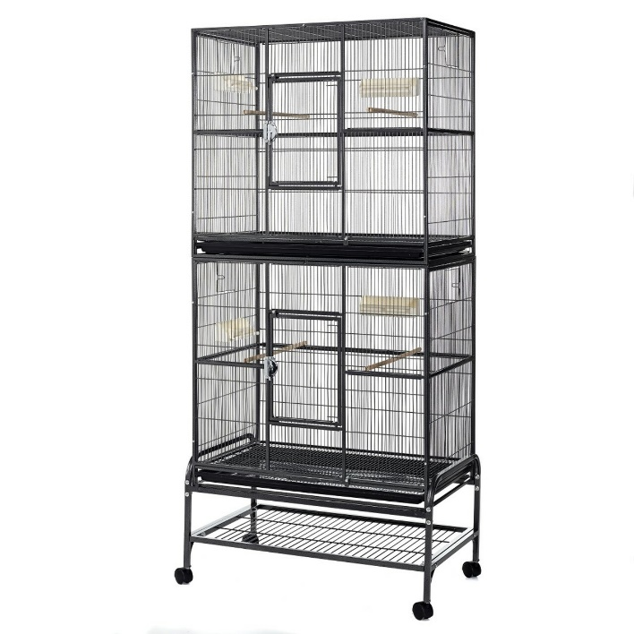

**Metal Rockford Double Rat, Ferret & Chinchilla Cage**

Dimensions: 81cm x 54cm x 152cm (183cm with stand)

Bar spacing: 10mm

Currently available at:

<https://www.littlepetwarehouse.co.uk/products/metal-rockford-double-rat-ferret-chinchilla-cage.html>

https://www.ebay.co.uk/p/1010006792

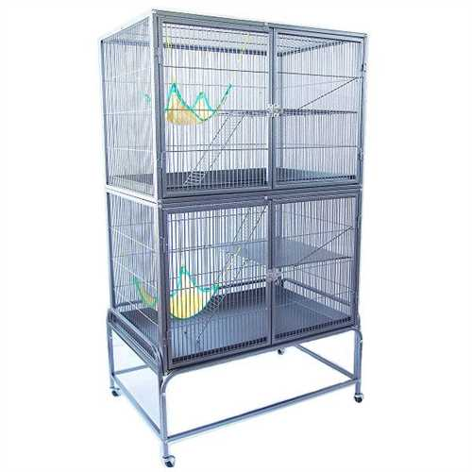

**Pet Planet Rat & Ferret Cage**

Dimensions: 96cm x 63cm x 122cm (159cm with stand)

Bar spacing: 14mm

Currently available at:

<https://www.petplanet.co.uk/p28577/rat_and_ferret_cage_by_petplanet.aspx?ptm_source=google&ptm_medium=shopping&ptm_campaign=40to50_68616&campaign=439957091&adgroup=33472599131&keyword=&gclid=Cj0KCQjwvO2IBhCzARIsALw3ASpVb0Mjl2M1bINlT38lWhnnqbRvKi4zrp83fB4CbmFp-9jwpzk2wSwaAktAEALw_wcB>

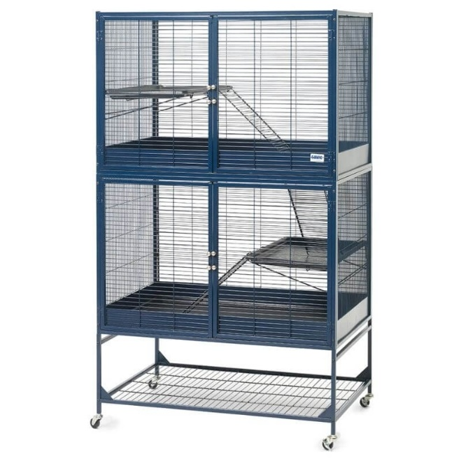

**Rat & Ferret Cage Royal Suite Dual Level Luxury**

Dimensions: 95cm x 63cm x 120cm (159cm with stand)

Bar spacing: 13mm

Currently available at:

<https://www.onbuy.com/gb/rat-and-ferret-cage-royal-suite-dual-level-luxury~c18043~p6649954/?exta=gshp&stat=eyJpcCI6IjMyOS45OTAwIiwiZHAiOm51bGwsImxpZCI6OTE3MDg0NCwicyI6bnVsbCwidCI6MTYyODc1OTY2NSwiYm1jIjoiMi41In0=&lid=9170844&gclid=Cj0KCQjwvO2IBhCzARIsALw3ASrXb0dV2Mv1gG8nYWCKm2EoLdZf17WSMG8lGpwtpi7o0PeIb8ugzWcaAqwIEALw_wcB>

Suitable exercise wheels

Chinchillas require an exercise wheel roughly 14-16 inches in size. Plastic wheels should be avoided for chinchillas. Wooden exercise wheels are available but tend not to last long due to getting gnawed on and then becoming unsafe. Metal wheels are strong and sturdy and can also be homemade.

<https://www.tictacwheels.co.uk/metal-wheels?page=2>

https://www.youtube.com/watch?v=2ClycBagr-U

Homemade accommodation

Due to the lack of suitable accommodation available on the market, many pet owners are now creating their own small animal enclosures. Here are some examples and ideas:

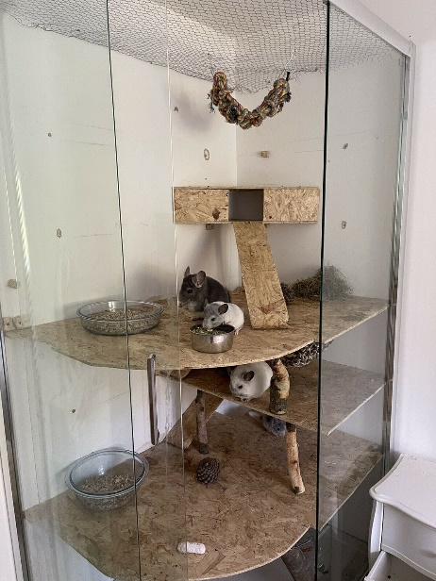

Chinchilla enclosure made from an old shower cubicle.

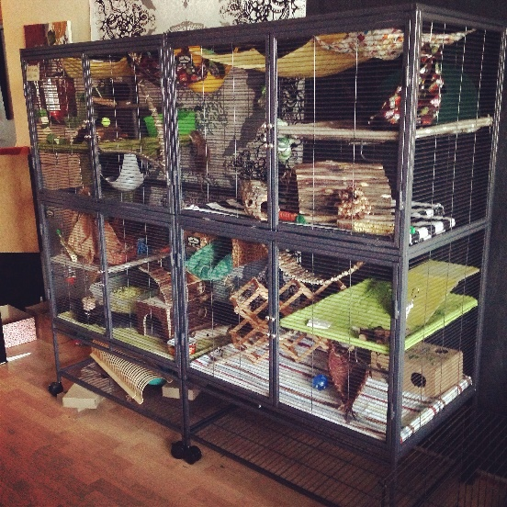

Two cages joined together to create a larger living space.