Cat scratching post 1

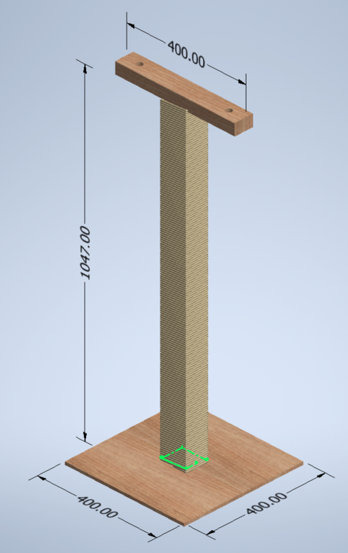
Parts list
 | Description | Size | Qty
1 | Plywood base | 400 x 400 x 9mm | 1
2 | Main post | 1m | 2
3 | Top bar | 0.4m | 1
4 | Sisal rope | 6mm | 54m
5 | Cross dowel bolts | M6 x 50mm | 8
6 | Inset Nuts | M6 x 13mm | 8
7 | Carpet | 600 x 600mm | 1

The scratching post has a footprint of a 400mm square and a height a little over a meter. This can be adjusted to suit, a 1m high post will leave no waste if starting with a standard 2.4m length of timber.
The main post is made from pairs of 63 x 38mm CLS timber wrapped in 6mm Sisal rope. The plywood is wrapped in carpet.
The post is assembled using M6 Cross dowel bolts that allows for it to be disassembled into its core components.

Rope
This design calls for a 6mm rope with a 1m post. As such we need 54m of rope at a cost of £7.83. If you decide to use a different size combination, you’ll need the rope diameter and the height of the post to calculating the length required. This table should help.
The price has been calculated based on the per meter cost of rope from a 220m coil being £0.15 at 6mm, £0.26 at 8mm and £0.34 at 10mm.
Post height | 6mm | 8mm | 10mm
0.5m | 27m (£3.92) | 21m (£5.42) | 18m (£6.07)
0.75m | 41m (£5.95) | 32m (£8.26) | 26m (£8.76)
1m | 54m (£7.83) | 42m (£10.84) | 35m (£11.80)

Calculator: https://www.katzen-deko.com/en/content/10-Sisal-calculator
Rope prices: https://www.ropesdirect.co.uk/sisal-rope-by-the-coil.html

Wood
As a 400mm square the plywood base can be cut from half of a standard 0.81 x 0.41m sheet of ply from B&Q (£12). While this would be the best method to have minimum wastage, it is the most expensive method for cost per meter at £36m².
For the CLS timber, if buying 2.4m lengths you’ll only need one piece at £3.47. The cut list as such:
Part No. | Cut length | Qty | Notes
2 | 1000 mm | 2 | Main scratching post, two pieces screwed together on their widest face.
3 | 400 mm | 1 | Mounted horizontally on top of the main post. With holes drilled into the timber it provides a place to tie cat toys on.

Carpet
It is recommended to wrap the base in carpet to improve the appearance and make it softer. Make sure to cut the hole for the post before gluing to the plywood and to not cover the bolt holes underneath. The parts list calls for a 600mm square which will give a 100mm overlap on each edge.

Total Cost
To calculate the estimated cost of this scratching post we have to consider whether the material is being bought as part of a larger order (taking advantage of bulk discount) and whether there is a minimum amount that can be bought.
As such there are two costs listed. The total price to buy all the materials, and how much of that cost is attributed to the tower. Please note the costs below don’t take into account shipping or delivery charges.
Material | Material size | Qty | Material cost | Amount required | Tower cost
Plywood | 0.81m x 0.41m x 9mm | 1 | £12 | 50% | £6
CLS timber | 2.4m x 63mm x 38mm | 1 | £3.47 | 1 | £3.47
Sisal rope | 6mm | 220m | £31.92 | 54m | £7.83
Total |  |  | £47.39 |  | £17.30

For fixings and consumables, they’re typically best bought from Screwfix or Toolstation
Description | Size | Pack qty | Cost | Required
Cross dowel bolt | 6mm x 50mm | 50 | £3.29 | For assembling parts
Insert Nut | M6 x 13mm | 50 | £3.69 | For assembling parts
Wood screw | 5mm x 60mm | 100 | £4.49 | For joining CLS post pairs together
Spray adhesive | - | 500ml | £4.79 | For gluing down the carpet
 |  | Total | £16.26

