**Gerbil Accommodation**

**Minimum Size Requirements for 2 – 4 gerbils:**

**100cm x 40cm x 40cm**

Gerbil accommodation should allow sufficient space for burrowing and digging whilst also housing ample enrichment. There is a currently a significant lack of appropriate accommodation for gerbils available on the market but there are many options that can be adapted such as aquariums and ‘Detolf’ ikea units to create a suitable space.

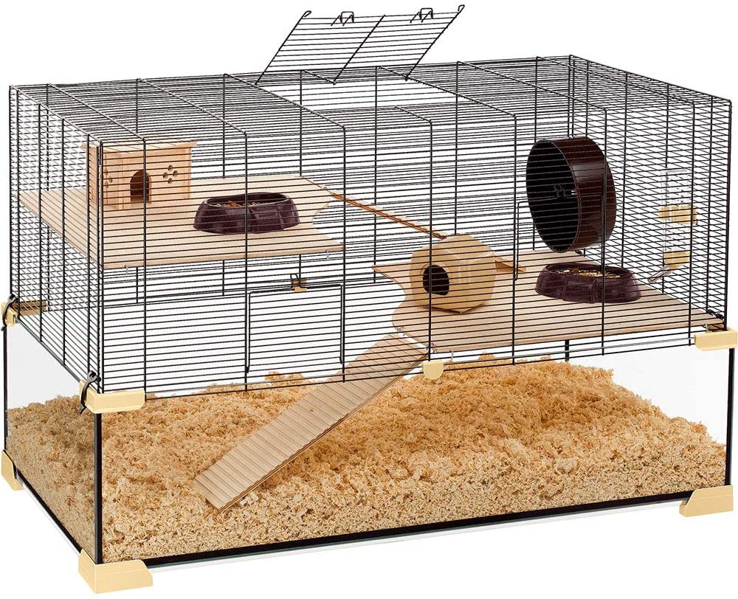

**Ferplast Karat 100**

Dimensions: 100cm x 61cm x 50cm

**Small animal tank – no platforms**

Jungle pets £199.99

100 x 50 x 50cm

[Small animal tank - no platforms various sizes (junglepets.co.uk)](https://www.junglepets.co.uk/small-animal-tank----no-platforms-various-sizes-2546-p.asp)

**Small animal tank – with platforms**

Jungle pets £204.99

100 x 50 x 50cm

[Design 3 Tank with lid and 2 corner shelves and platform accross entire back (junglepets.co.uk)](https://www.junglepets.co.uk/design-3-tank-with-lid-and-2-corner-shelves-and-platform-accross-entire-back-2559-p.asp)

**Diversa aquarium**

Amazon £159.95

100 x 40 x 40cm

Adaptation required: Needs a mesh lid

<https://www.amazon.co.uk/Diversa-Aquarium-Professional-Fish-Tank/dp/B07DXQSYM8/ref=asc_df_B07DXSZ1RQ/?tag=googshopuk-21&linkCode=df0&hvadid=309861873504&hvpos=&hvnetw=g&hvrand=17392619706195313457&hvpone=&hvptwo=&hvqmt=&hvdev=c&hvdvcmdl=&hvlocint=&hvlocphy=1006662&hvtargid=pla-563446264762&th=1>

Homemade accommodation

Due to the lack of suitable accommodation available on the market, many pet owners are now creating their own small animal enclosures. Here are some examples and ideas (please note we would not recommend the use of sawdust for gerbils as shown in the photos):

**Ikea ‘detolf’ display unit with a mesh topper**

163cm x 43cm x 37cm (without topper)

Although the width and height are less than the minimum requirements, this is more than made up for in length giving a very large space overall and allowing for deep substrate. It can be extended with the addition of a topper, or otherwise requires a mesh lid to be made and fitted.

Note: Detolf photographed has been set up for mice not gerbils.

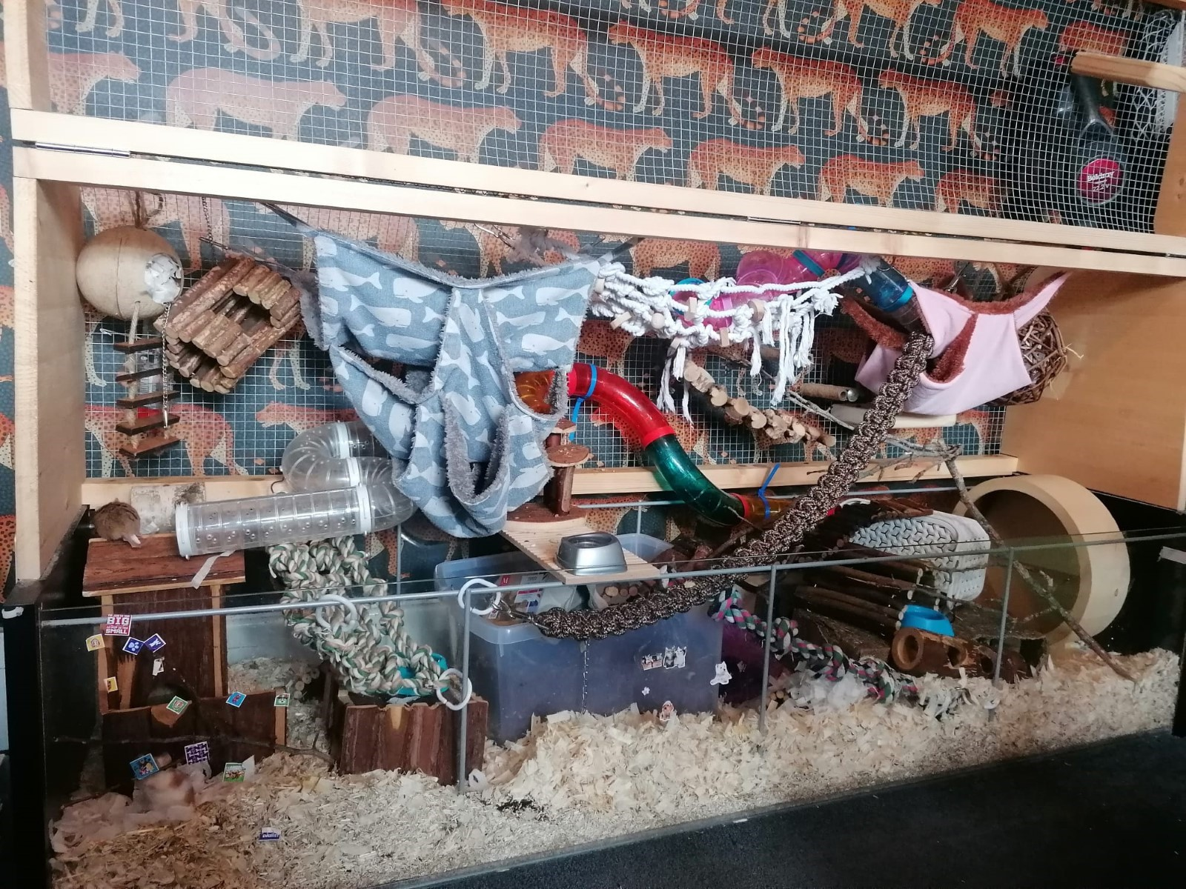

Detolf can be purchased here: <https://www.ikea.com/gb/en/p/detolf-glass-door-cabinet-white-80269122/>

Lids and toppers often available to purchase at [www.etsy.com](http://www.etsy.com/)

Currently available here;

<https://www.etsy.com/uk/listing/1156193970/ikea-detolf-cage-lids?ga_order=most_relevant&ga_search_type=all&ga_view_type=gallery&ga_search_query=ikea+detolf+lid&ref=sr_gallery-1-3&organic_search_click=1>

Or here;

<https://www.etsy.com/uk/listing/1354588991/detolf-cage-lid?ga_order=most_relevant&ga_search_type=all&ga_view_type=gallery&ga_search_query=ikea+detolf+lid&ref=sc_gallery-1-1&frs=1&plkey=ef9fa058b491b333eadd0519ecab68545a20c9a0%3A1354588991>

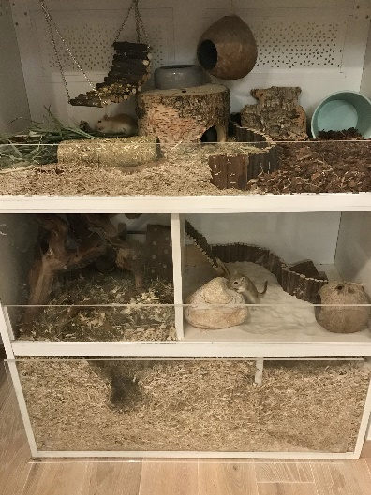

Gerbil accommodation made from Ikea units.

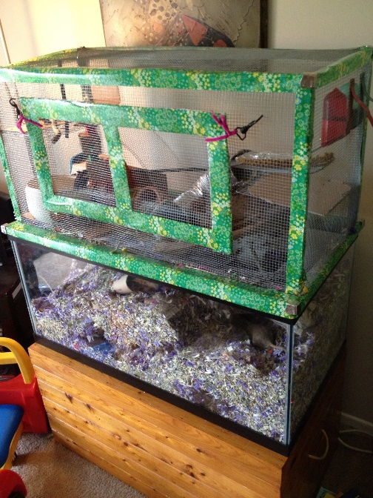

Gerbil tank extended to create larger living space.

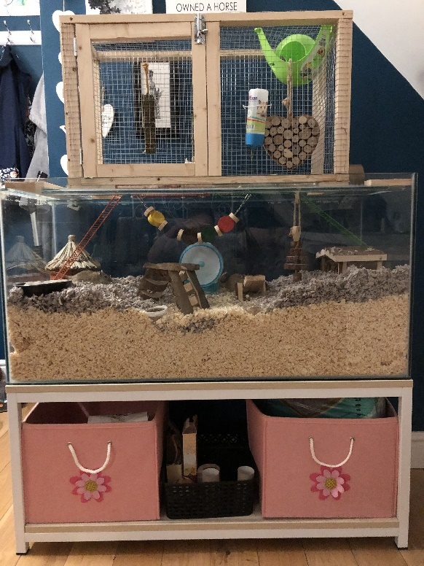

Gerbil tank extended allowing more space for burrowing.